HOMEWORK-3

- Write a C program to store n elements in an array using dynamic memory allocation and find the largest number.

#include <stdio.h>
#include <stdlib.h>

int main() {
int n, i, *a, max;

printf("Enter number of elements: ");
scanf("%d", &n);

a = (int *)malloc(n * sizeof(int));

printf("Enter elements:\n");
for(i = 0; i < n; i++)
scanf("%d", &a[i]);

max = a[0];
for(i = 1; i < n; i++) {
if(a[i] > max)
max = a[i];
}

printf("Largest = %d", max);

free(a);
return 0;
}

OUTPUT:
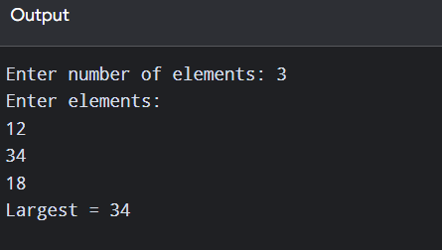
- Print an array in reverse order using pointers.

#include <stdio.h>

int main() {
int a[100], n, i;
int *p;

printf("Enter size: ");
scanf("%d", &n);

printf("Enter elements:\n");
for(i = 0; i < n; i++)
scanf("%d", &a[i]);

p = &a[n - 1];

printf("Reverse array:\n");
for(i = 0; i < n; i++) {
printf("%d ", *p);
p--;
}

return 0;
}

OUTPUT:
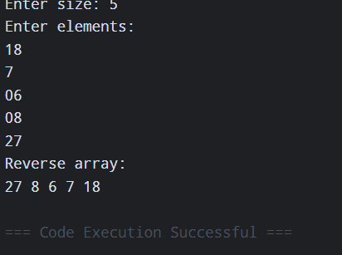

- Write a C program to store information of students using structure and sort them by name.
#include <stdio.h>
#include <string.h>

struct Student {
int regno;
char name[30];
float mark;
};

int main() {
struct Student s[50], temp;
int n, i, j;

printf("Enter number of students: ");
scanf("%d", &n);

// Input
for(i = 0; i < n; i++) {
printf("\nStudent %d\n", i + 1);

printf("Reg No: ");
scanf("%d", &s[i].regno);

printf("Name: ");
scanf("%s", s[i].name);

printf("Mark: ");
scanf("%f", &s[i].mark);
}

// Sort by name (Alphabetical)
for(i = 0; i < n - 1; i++) {
for(j = i + 1; j < n; j++) {
if(strcmp(s[i].name, s[j].name) > 0) {
temp = s[i];
s[i] = s[j];
s[j] = temp;
}
}
}

// Display
printf("\nStudents Sorted by Name\n");
printf("RegNo\tName\tMark\n");

for(i = 0; i < n; i++) {
printf("%d\t%s\t%.2f\n",
s[i].regno,
s[i].name,
s[i].mark);
}

return 0;
}
OUTPUT:
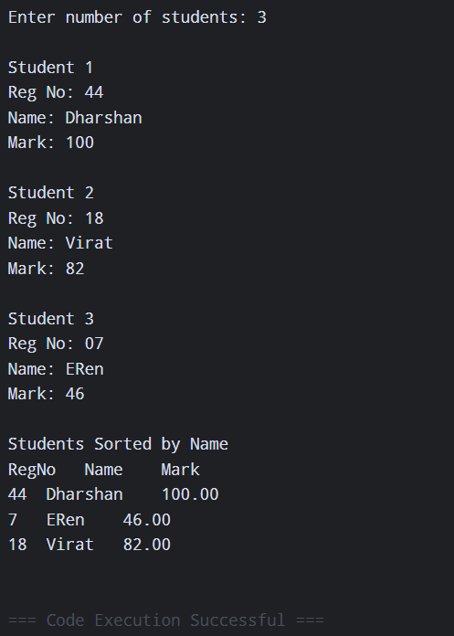

- Write a C program to add n distances given in inch–feet system using structures.
#include <stdio.h>

struct Distance {
int feet;
int inch;
};

int main() {
struct Distance d1, d2, sum;

printf("Enter first distance (feet inch): ");
scanf("%d%d", &d1.feet, &d1.inch);

printf("Enter second distance (feet inch): ");
scanf("%d%d", &d2.feet, &d2.inch);

sum.feet = d1.feet + d2.feet;
sum.inch = d1.inch + d2.inch;

if(sum.inch >= 12) {
sum.feet++;
sum.inch -= 12;
}

printf("Total Distance = %d feet %d inch", sum.feet, sum.inch);

return 0;
}

OUTPUT:
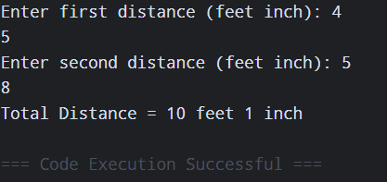

- Write a C program to add two complex numbers by passing structure to a function.

#include <stdio.h>

struct Complex {
int real;
int imag;
};

struct Complex add(struct Complex a, struct Complex b) {
struct Complex c;
c.real = a.real + b.real;
c.imag = a.imag + b.imag;
return c;
}

int main() {
struct Complex c1, c2, result;

printf("Enter first complex number (real imag): ");
scanf("%d%d", &c1.real, &c1.imag);

printf("Enter second complex number (real imag): ");
scanf("%d%d", &c2.real, &c2.imag);

result = add(c1, c2);

printf("Sum = %d + %di", result.real, result.imag);

return 0;
}

OUTPUT:
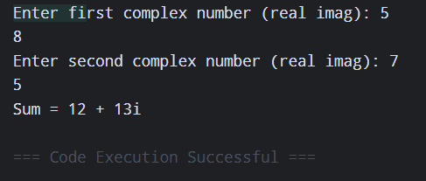

- Write a C program to maintain an Inventory Management System using Structure.
#include <stdio.h>

struct Item {
int id;
char name[30];
int quantity;
float price;
};

int main() {
struct Item item[20];
int n, i;
float total;

printf("Enter number of items: ");
scanf("%d", &n);

// Input item details
for(i = 0; i < n; i++) {
printf("\nItem %d\n", i + 1);

printf("Item ID: ");
scanf("%d", &item[i].id);

printf("Item Name: ");
scanf("%s", item[i].name);

printf("Quantity: ");
scanf("%d", &item[i].quantity);

printf("Price: ");
scanf("%f", &item[i].price);
}

// Display inventory
printf("\n----- INVENTORY DETAILS -----\n");
printf("ID\tName\tQty\tPrice\tTotal\n");

for(i = 0; i < n; i++) {
total = item[i].quantity * item[i].price;

printf("%d\t%s\t%d\t%.2f\t%.2f\n",
item[i].id,
item[i].name,
item[i].quantity,
item[i].price,
total);
}

return 0;
}

OUTPUT:
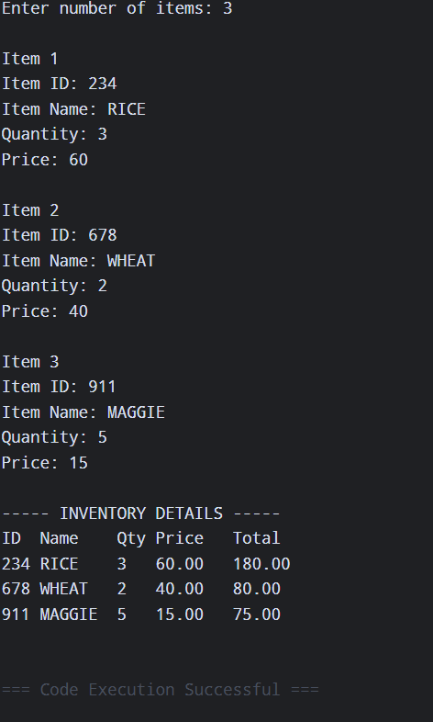

- Write a C program for decimal to binary, octal and hexadecimal conversion.
#include <stdio.h>

int main() {
int n;

printf("Enter decimal number: ");
scanf("%d", &n);

printf("Binary: ");

int temp = n, bin[32], i = 0;

while(temp > 0) {
bin[i++] = temp % 2;
temp /= 2;
}

while(i--)
printf("%d", bin[i]);

printf("\nOctal: %o", n);
printf("\nHexadecimal: %X", n);

return 0;
}

OUTPUT:
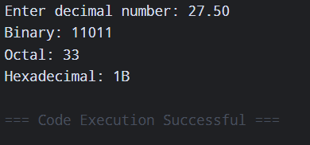

- Write a C program to calculate the difference between two time periods.
#include <stdio.h>

struct Time {
int hr;
int min;
int sec;
};

int main() {
struct Time t1, t2, diff;

printf("Enter first time (h m s): ");
scanf("%d%d%d", &t1.hr, &t1.min, &t1.sec);

printf("Enter second time (h m s): ");
scanf("%d%d%d", &t2.hr, &t2.min, &t2.sec);

if(t2.sec > t1.sec) {
t1.sec += 60;
t1.min--;
}

diff.sec = t1.sec - t2.sec;

if(t2.min > t1.min) {
t1.min += 60;
t1.hr--;
}

diff.min = t1.min - t2.min;
diff.hr = t1.hr - t2.hr;

printf("Difference = %d:%d:%d",
diff.hr, diff.min, diff.sec);

return 0;
}

OUTPUT:
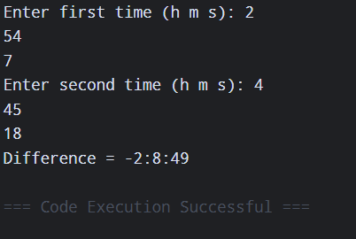

- Write a C program to create an Employee Management System using structures.
#include <stdio.h>

struct Employee {
int id;
char name[30];
float salary;
};

int main() {
struct Employee e[20];
int n, i;

printf("Enter number of employees: ");
scanf("%d", &n);

for(i = 0; i < n; i++) {
printf("\nEmployee %d\n", i + 1);
printf("ID: ");
scanf("%d", &e[i].id);
printf("Name: ");
scanf("%s", e[i].name);
printf("Salary: ");
scanf("%f", &e[i].salary);
}

printf("\nEmployee Details\n");
for(i = 0; i < n; i++) {
printf("%d %s %.2f\n",
e[i].id, e[i].name, e[i].salary);
}

return 0;
}

OUTPUT:
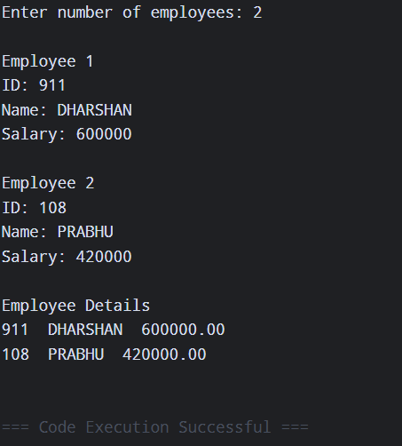

10. Write a C program to calculate area and perimeter of a rectangle and area of a triangle using function pointers.
#include <stdio.h>

float rectArea(float l, float b) {
return l * b;
}

float rectPerimeter(float l, float b) {
return 2 * (l + b);
}

float triArea(float b, float h) {
return 0.5 * b * h;
}

int main() {
float l, b, h;
float (*fp)(float, float);

printf("Enter length and breadth: ");
scanf("%f%f", &l, &b);

fp = rectArea;
printf("Rectangle Area = %.2f\n", fp(l, b));

fp = rectPerimeter;
printf("Rectangle Perimeter = %.2f\n", fp(l, b));

printf("Enter triangle height: ");
scanf("%f", &h);

fp = triArea;
printf("Triangle Area = %.2f", fp(b, h));

return 0;
}

OUTPUT:
